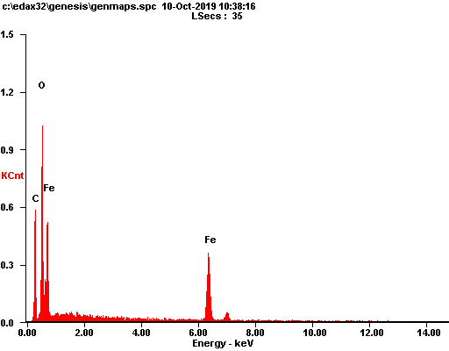

|  |  |  |
| --- | --- | --- |
| ***Element*** | ***Wt%*** | ***At%*** |
| ***CK*** | 23.76 | 44.79 |
| ***OK*** | 24.06 | 34.05 |
| ***FeK*** | 52.17 | 21.15 |
| ***Matrix*** | Correction | ZAF |

